LAB 5 TUTORIAL

This tutorial covers:
Chapter 6- Files

- Basic Multiple Choice and Subjective Question

- To allow file access in a program, you must #include this header file.
A) file
B) fileaccess
C) fstream
D) cfile
Answer: C

- A file ________ is a small holding section of memory that file-bound information is first written to.
A) name
B) number
C) buffer
D) segment
Answer: C

- This may be used to write information to a file.
A) cout object
B) pen object
C) output object
D) stream insertion operator
Answer: D

- To write data to a file, you define an object of this data type.
A) outputFile
B) ifstream
C) fstream
D) ofstream
Answer: D

To read data from a file, you define an object of this data type.
A) inputFile
B) ifstream
C) fstream
D) ofstream
Answer: B

- Assuming outFile is a file stream object and number is a variable, which statement writes the contents of number to the file associated with outFile?
A) write(outFile, number);
B) outFile >> number;
C) outFile << number;
D) number >> outFile;
Answer: C

- Assuming dataFile is a file stream object, the statement:

dataFile.close();

A) is illegal in C++
B) needs a filename argument to execute correctly
C) closes a file
D) is legal but risks losing valuable data
Answer: C

- A file must be ________ before data can be written to or read from it.
A) closed
B) opened
C) buffered
D) initialized
Answer: B

- How many times will the following loop display "Hello"?

for (int i = 0; i < 20; i++)
cout << "Hello!" << endl;

A) 20
B) 19
C) 21
D) An infinite number of times
Answer: A

- How many times will the following loop display "Hello"?

for (int i = 1; i < 20; i++)
cout << "Hello!" << endl;

A) 20
B) 19
C) 21
D) An infinite number of times
Answer: B

- Application Questions on Loops and Files

- Write a c++ syntax to test a file stream object to detect if an open operation failed
infile.open("test.txt");
if (!infile)
{
cout << "File open failure!";
}

- Write a C++ program by using loops to write number 1 to 100 in the data file. The program will automatically create a simple file name ‘lab5.txt’ if it not yet exists. The program must display “file successfully created!” once created.
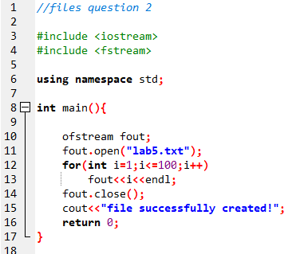
- Write a user-defined function in C++ to read the content from a text file ‘display.txt’, count and display the number of alphabets present in it. First, create a text file name as ‘display’, the file should contain below text:
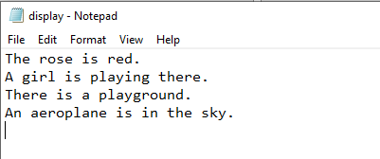
Your output should be:
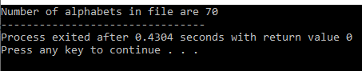
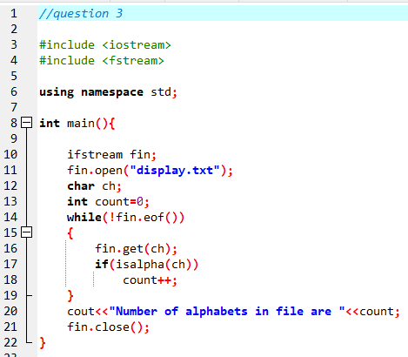

- Write a C++ program, which initializes a string variable to the content "Learning Computer science and learn to code is fun!" and outputs the string to the disk file ‘out.txt’. Include all the header files if required. Your program should display the “file has been successfully created”. After execution, you should have the text file name ‘out’ in your pc and text written in it as screenshot below.
